NAME-NISHI JAYESH PATEL

ROLL NO.- L003

MSc(DS&AI)

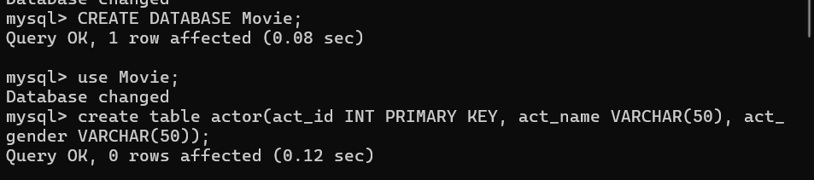

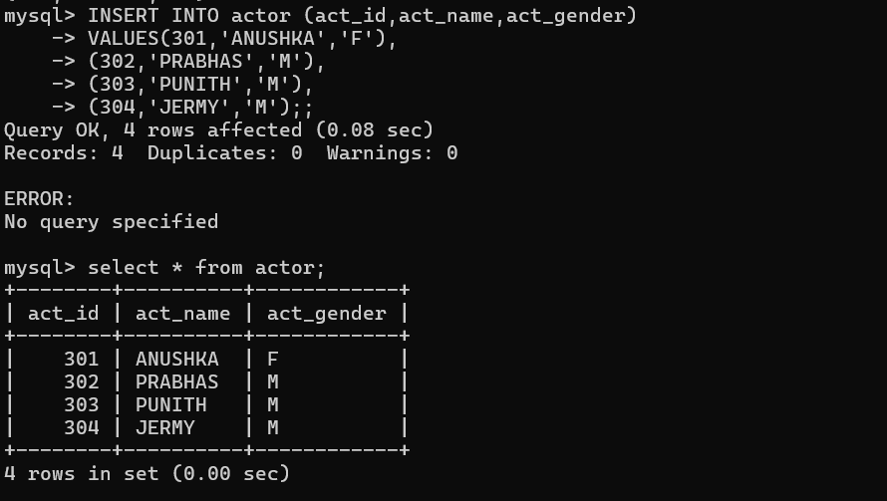



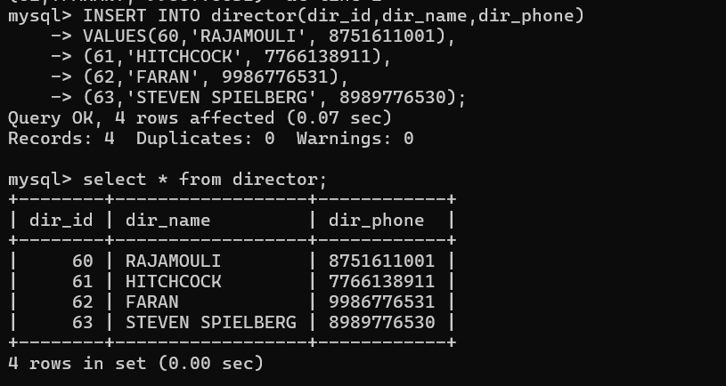

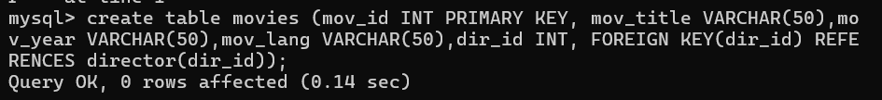

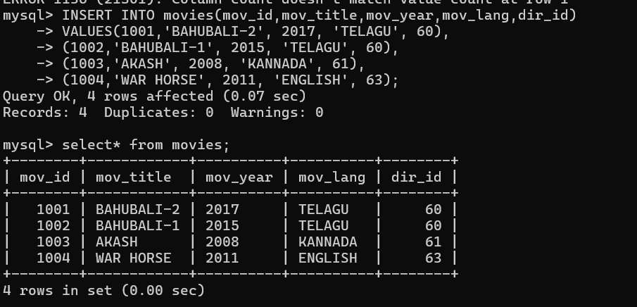



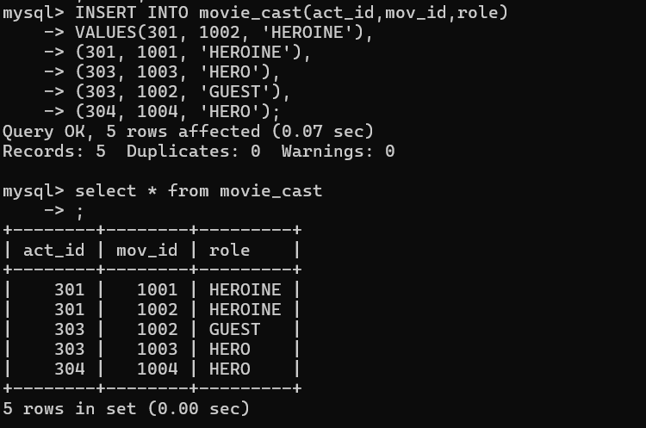



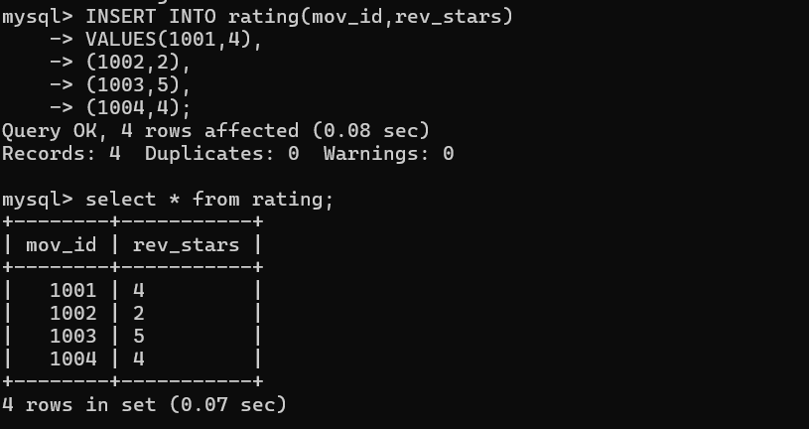

1. List the titles of all movies directed by ‘Hitchcock’.

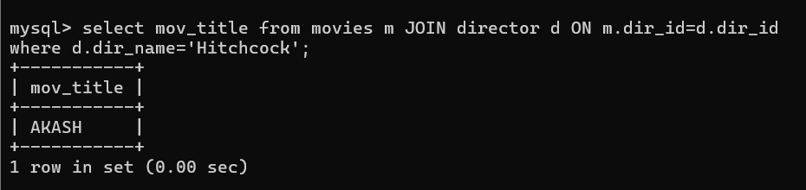

2. Find the movie names where one or more actors acted in two or more movies.

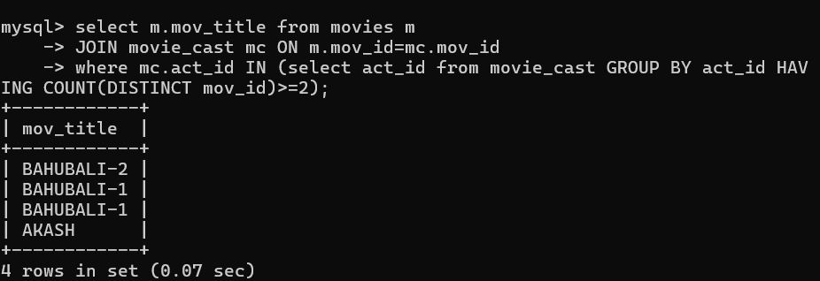

1. List all actors who acted in a movie before 2000 and also in a movie after 2015 (use JOIN operation).

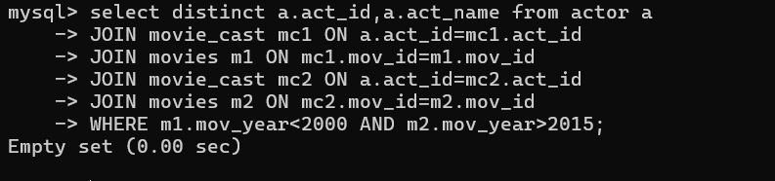

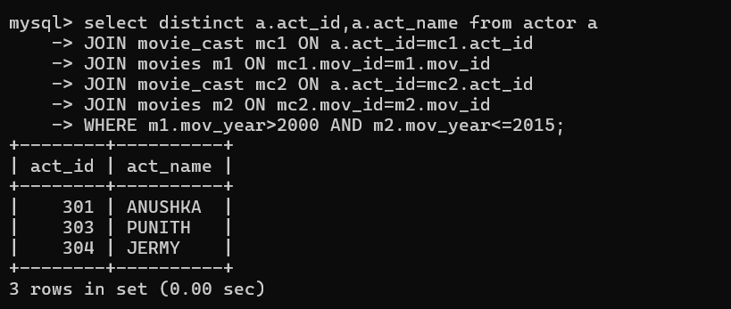

4. Find the title of movies and number of stars for each movie that has at least one

rating and find the highest number of stars that movie received. Sort the result by

movie title

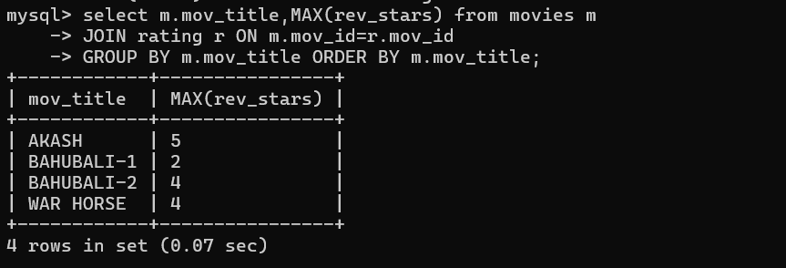

5.Update rating of all movies directed by ‘Steven Spielberg’ to 5.

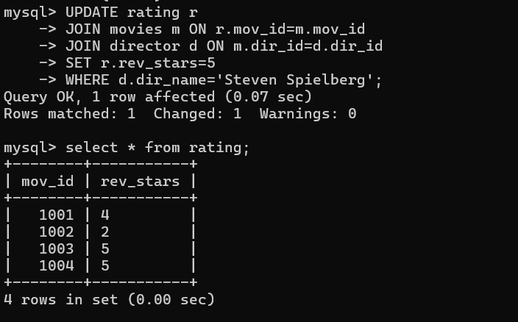

Q3.



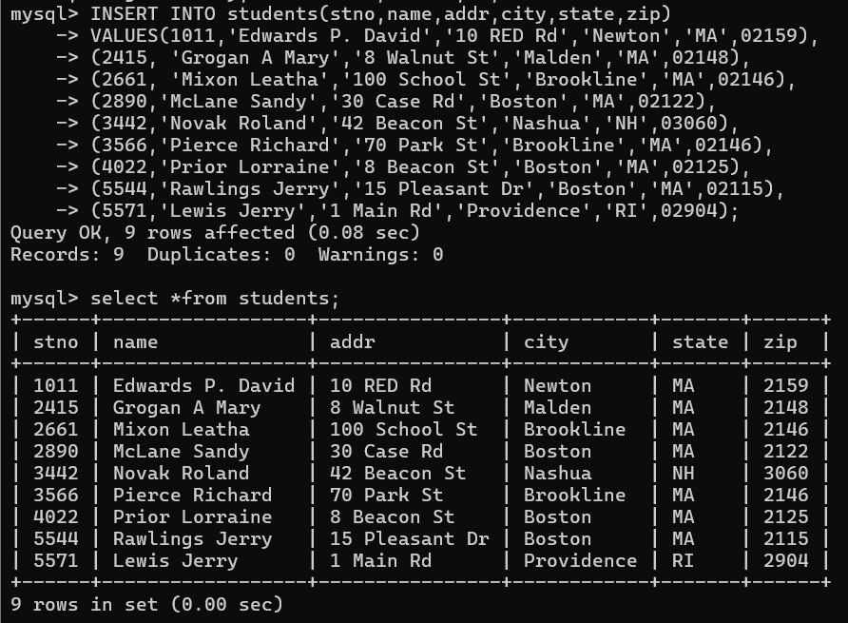



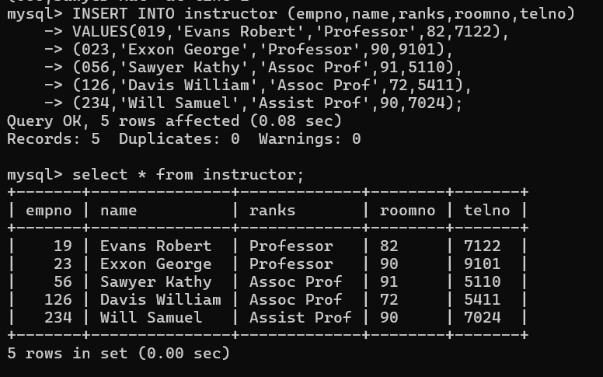

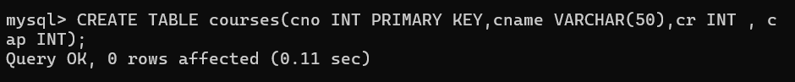

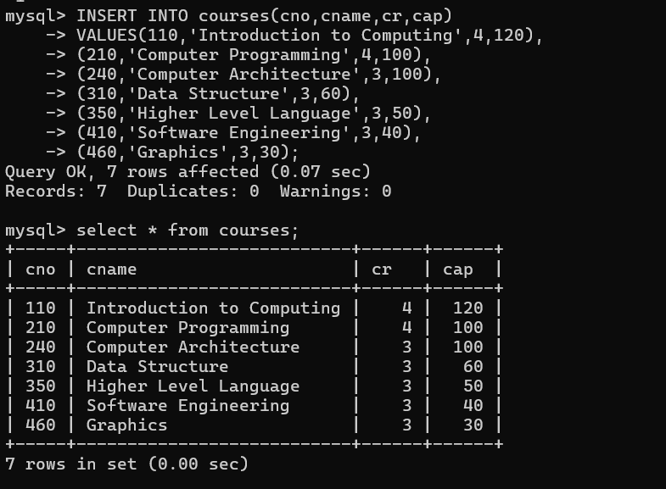

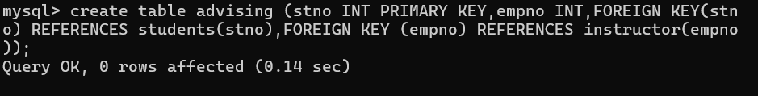

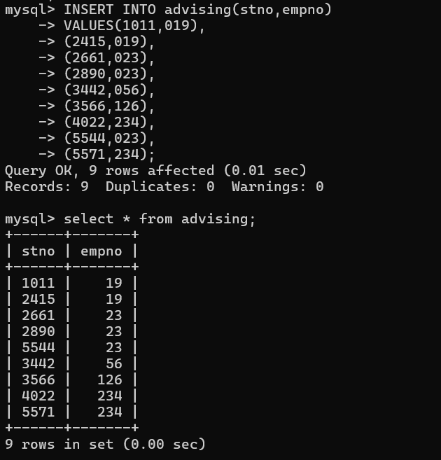

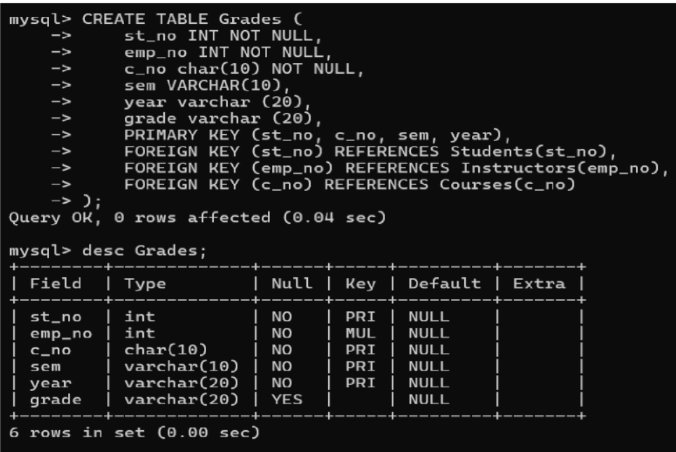

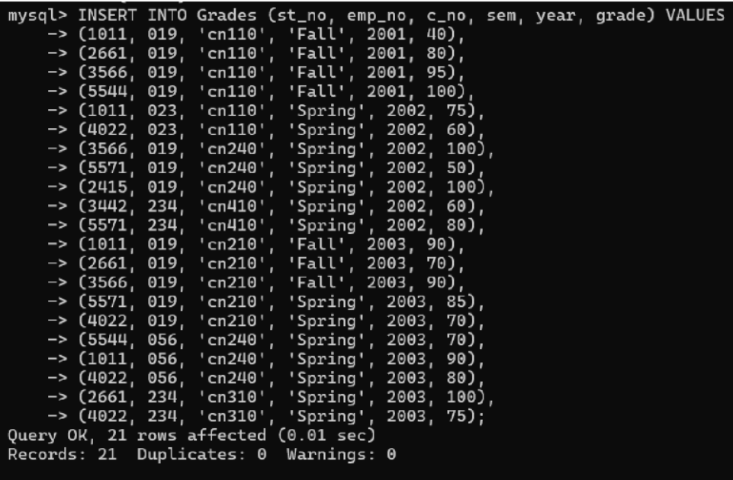

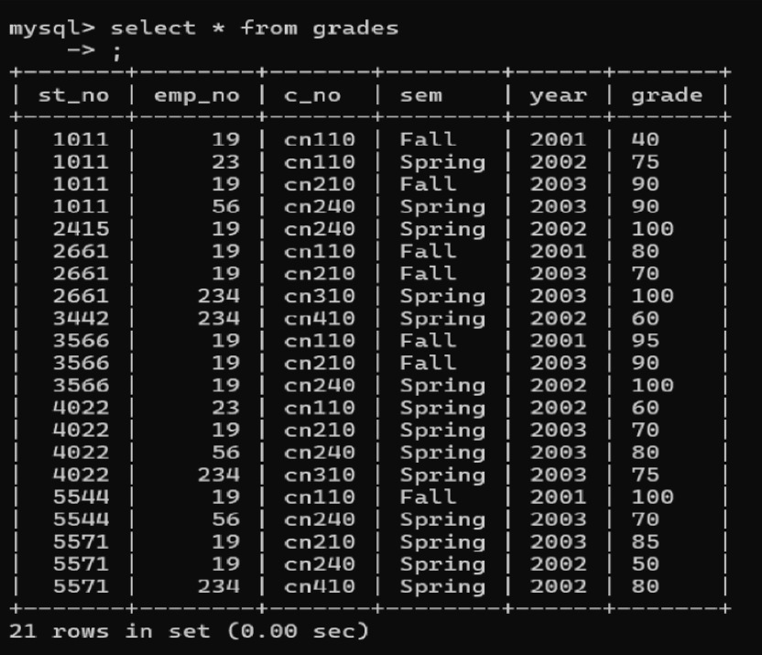

1.Find the names of students who took some four-credit courses.

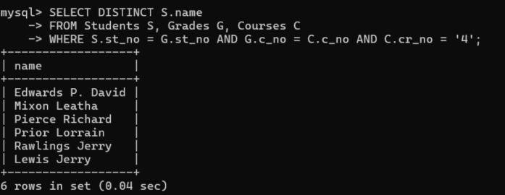

1. Find the names of students who took every four-credit course.

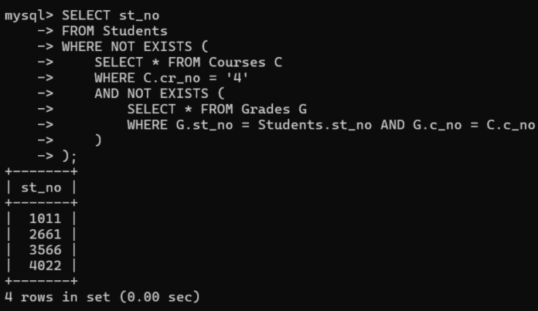

3. Find the names of students who took a course with an instructor who is also

their advisor.

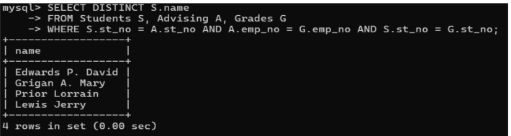

1. Find the names of students who took cs210 and cs310.

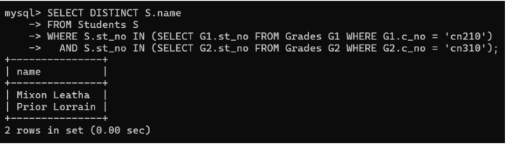

1. Find the names of all students whose advisor is not a full professor.

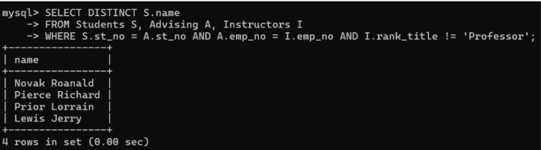

6. Find instructors who taught students who are advised by another instructor

who shares the same room.

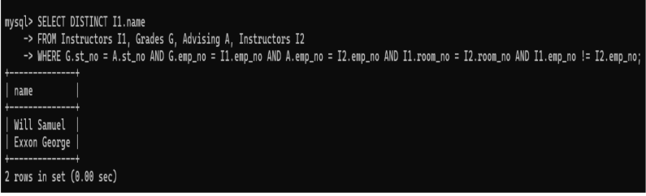

1. Find course numbers for courses that enroll exactly two students;

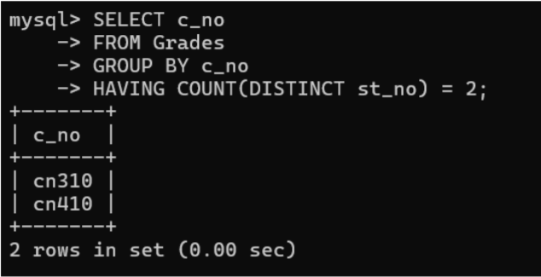

8. Find the names of all students for whom no other student lives in the same

city.

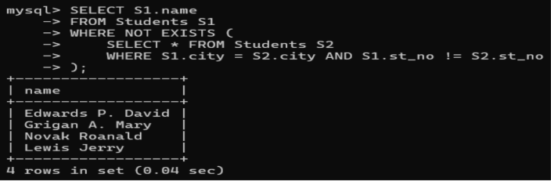

9. Find course numbers of courses taken by students who live in Boston and

which are taught by an associate professor.

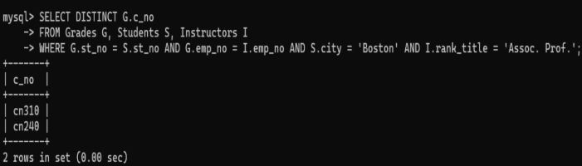

10. Find the telephone numbers of instructors who teach a course taken by any

student who lives in Boston.

